You have to download the Differential Evolution code and the immoptibox

http://www1.icsi.berkeley.edu/~storn/code.html#matl
http://www2.imm.dtu.dk/~hbn/immoptibox/
Then, place it into the directory structure as follows:
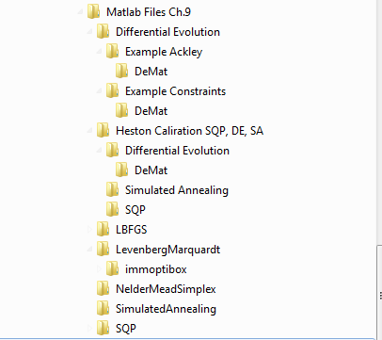

Of course you can also use any other optimizer, e.g. some from the Matlab fileexchange!!!

